INTERNSHIP PROJECT REPORT ON
CLICK AD PREDICTION
SUBMITTED BY
PRANAMYA
(U05SD22S0109)
AT
ZEPHYR TECHNOLOGIES AND SOLUTIONS PVT LTD.



5th Floor, Oberle Towers, Balmatta road, Bendoor,
Mangalore, Karnataka-575002, India

ACKNOWLEDGEMENT

We would like to express our sincere gratitude to Zephyr Technologies for their invaluable support and guidance throughout our course. Their expertise and dedication have greatly contributed to our learning experience, helping us acquire the skills necessary to successfully undertake and complete our project. The resources and insights provided by Zephyr Technologies have been instrumental in shaping our understanding and approach, and we are deeply thankful for their commitment to our development.

Thank you, Zephyr Technologies, for being an integral part of our journey.

ABSTRACT

Predicting customer ad click is a massive-scale learning problem that is central to the multi-billion dollar online advertising industry. It helps us to analyse whether a user will click on an online advertisement based on various features and historical data. This task is crucial for digital marketing, as it helps companies optimize their advertising strategies, allocate budgets effectively, and maximize returns on investment.
Machine learning has become a vital tool in predicting ad clicks, transforming how online advertising operates. We can also explore some of the challenges that arise in a real-world system that may appear at first to be outside the domain of traditional machine learning research. These include useful tricks for memory savings, methods for assessing and visualizing performance, practical methods for providing confidence estimates for predicted probabilities, calibration methods, and methods for automated management of features. By analysing large datasets that include user behaviour, demographic information, and ad characteristics, machine learning algorithms can identify patterns and predict the likelihood of a user clicking on an advertisement. Techniques such as logistic regression, decision trees, gradient boosting, and deep learning are commonly used to model these relationships. These predictive models enable advertisers to optimize their ad campaigns by targeting users who are more likely to engage, thereby increasing click-through rates and maximizing return on investment. Furthermore, machine learning models continuously learn and adapt from new data, allowing them to improve accuracy over time and respond dynamically to changing user behaviours and market trends. This approach enhances the efficiency of digital marketing strategies, leading to more personalized advertising and better user experiences.
The aim of predicting ad clicks is to enhance the effectiveness and efficiency of digital advertising by identifying which ads are most likely to be clicked by users. This involves leveraging machine learning models to analyse patterns in user behaviour, ad content, and contextual information to forecast the probability of a click.
INDEX

- INTRODUCTION 05
- BACKGROUND STUDY 06
- PROBLEM STATEMENT 07
- DATASET 08
- METHODOLOGY 10
- IMPLEMENTATION 12
- RESULT AND DISCUSSION 17
- SUMMARY AND CONCLUSION 18
- SCOPE FOR FUTURE ENHANCEMENT 19
- APPENDEX 20
- BIBLOGRAPHY 22

1) INTRODUCTION

The online advertisement industry has become a multi-billion industry and predicting Ad CTR (click-through rate) is now central to it. Nowadays, different types of advertisers and search engines rely on modelling to predict ad CTR accurately. Predicting customer ad clicks is a crucial part of digital marketing. By predicting ad clicks, advertisers can optimize their campaigns by targeting users who are more likely to respond positively, thereby improving the effectiveness of ads, maximizing return on investment, and enhancing user experience through more relevant and personalized content. This predictive capability is essential for digital marketing strategies, allowing companies to allocate resources efficiently and achieve better outcomes in a competitive online environment.

Consider an online retail company that wants to promote its new line of summer clothing through digital ads. By using a machine learning model to predict ad clicks, the company can optimize its advertising strategy in several ways like analysing user data such as browsing history, purchase behaviour, and demographic information to predict which users are most likely to be interested in summer clothing. As a result, the company can show ads specifically to these users, increasing the chances of clicks and engagement. By predicting which ads are more likely to be clicked, the company can allocate its budget more effectively, focusing spending on high-potential users. This reduces waste on ads shown to users who are unlikely to click, maximizing return on investment. Hence by predicting ad clicks accurately, the online retail company ensures that its advertising efforts are more targeted, cost-effective, and user-friendly, ultimately driving higher sales and customer satisfaction.

In this blog, we will be predicting the ad click-through rate using the machine learning approach. Before that, let us first understand few important concepts and a general approach followed by searched engines to decide which ads to display.
CTR: It is the metric used to measure the percentage of impressions that resulted in a click. CTR = (Number of click-throughs/Number of impressions)*100%
Search ads: Advertisements that get displayed when a user searches for a certain keyword. Paid search advertising is a popular form of Pay per click (PPC) advertising in which brands or advertisers pay (bid amount) to have their ads displayed when users search for certain keywords.

2) BACKGROUND STUDY

Click ad prediction models are built on the foundation of understanding user behaviour and how it correlates with engagement with digital advertisements. Initially, simpler models like logistic regression were used to predict the probability of clicks based on basic features such as user demographics and historical click data. Over time, as more data became available and computational power increased, more sophisticated machine learning techniques like decision trees, random forests, gradient boosting machines, and deep learning models were developed to handle the complexity of click prediction.
These models analyse large datasets to capture intricate patterns and interactions between features, such as time of day, device type, ad format, and user browsing history, to improve prediction accuracy. The evolution of click prediction models has been driven by the need for more precise targeting and personalization in digital advertising, aiming to increase ad relevance, improve user experience, and optimize ad spend. As a result, modern click ad prediction models not only enhance the efficiency of marketing campaigns but also adapt in real-time to changing user behaviours and market trends, providing a dynamic tool for advertisers.
Machine learning helps in accurately predicting clicks which helps advertisers allocate their budgets efficiently, targeting users most likely to engage with their ads. The model helps decide where to place ads on websites to maximize visibility and click-through rates and by showing relevant ads, the model contributes to a more personalized and engaging online experience. It is simple and interpretable, but may not capture complex relationships between features and is more powerful in capturing non-linear relationships, but can be harder to interpret.

3) PROBLEM STATEMENT
Click ad prediction model is to predict whether a user will click on an ad or not. This is a binary classification problem, where the goal is to build a model that can accurately predict the likelihood of a user clicking on an ad based on various factors, such as the user's demographics, browsing history, and the ad's content. The model aims to help advertisers optimize their ad campaigns by identifying which ads are most likely to be clicked on, thus maximizing their return on investment.
Typically, the main source of income for search engines like Google is through advertisement. There are tons of companies that pay these search engines to display their ads when a user searches for a certain keyword. Here, our focus is on search ads and CTR, i.e. the amount is paid only when a user clicks on the link and redirects to the brand’s website.
Different advertisers approach these search engines with their ads and the bidding amount to display their ads. The main objective of these search engines is to maximize their revenue. So the question is how does a search engine decide which ads to display when a user searches for a certain keyword?

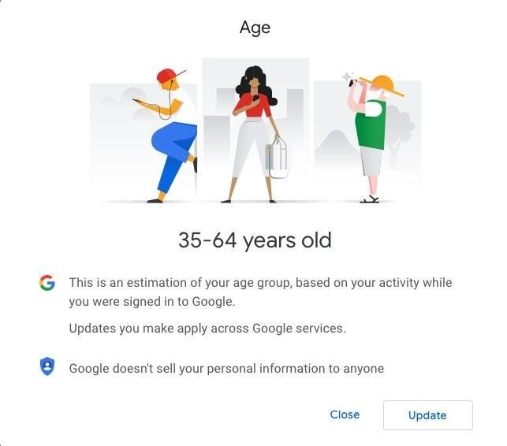

4) DATASET

The Click Ad Prediction dataset is used in this project from Kaggle.

About the Dataset:
It typically contains a wide range of features that represent different aspects of the advertising environment and user behaviour. These datasets are used to train machine learning models to predict whether a user will click on a given ad. Here is an overview of the types of data typically included:
- Daily Time Spent on Site: consumer time on site in minutes
- Age: customer age in years
- Area Income: Avg. Income of geographical area of consumer
- Daily Internet Usage: Avg. minutes a day consumer is on the internet
- Ad Topic Line: Headline of the advertisement
- City: City of consumer
- Male: Whether or not consumer was male
- Country: Country of consumer
- Timestamp: Time at which consumer clicked on Ad or closed window
- Clicked on Ad: 0 or 1 indicated clicking on Ad
DATASET:
Daily Time Spent on Site | Age | Area Income | Daily Internet Usage | Ad Topic Line | City | Male | Country | Timestamp | Clicked on Ad
68.95 | 35 | 61833.9 | 256.09 | Cloned 5thgeneration orchestration | Wrightburgh | 0 | Tunisia | 27-03-2016 00:53 | 0
80.23 | 31 | 68441.85 | 193.77 | Monitored national standardization | West Jodi | 1 | Nauru | 04-04-2016 01:39 | 0
69.47 | 26 | 59785.94 | 236.5 | Organic bottom-line service-desk | Davidton | 0 | San Marino | 13-03-2016 20:35 | 0
74.15 | 29 | 54806.18 | 245.89 | Triple-buffered reciprocal time-frame | West Terrifurt | 1 | Italy | 10-01-2016 02:31 | 0
68.37 | 35 | 73889.99 | 225.58 | Robust logistical utilization | South Manuel | 0 | Iceland | 03-06-2016 03:36 | 0
59.99 | 23 | 59761.56 | 226.74 | Sharable client-driven software | Jamieberg | 1 | Norway | 19-05-2016 14:30 | 0
88.91 | 33 | 53852.85 | 208.36 | Enhanced dedicated support | Brandonstad | 0 | Myanmar | 28-01-2016 20:59 | 0
66 | 48 | 24593.33 | 131.76 | Reactive local challenge | Port Jefferybury | 1 | Australia | 07-03-2016 01:40 | 1
74.53 | 30 | 68862 | 221.51 | Configurable coherent function | West Colin | 1 | Grenada | 18-04-2016 09:33 | 0

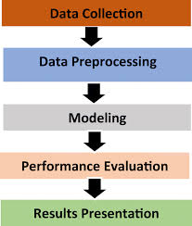

Figure 1.1: WORKING MECHANISM

5) METHODOLOGY

WORKING MECHANISM:
It represents a general workflow for building a machine learning model which can be applied to predict stock prices. Here's how each step would apply in that context:

- DATA COLLECTION
Data collection is a crucial step in building a click ad prediction model. The quality and comprehensiveness of the collected data directly impact the accuracy and effectiveness of the predictive model. For click ad prediction, data is gathered from various sources that capture different aspects of user behaviour, ad performance, and contextual factors.

- DATA PREPROCESSING
It involves preparing and cleaning the raw data to ensure that it is suitable for analysis and model training. This includes:
- Handling Missing Values: Replacing or removing missing price data.
- Feature Engineering: Creating new features from existing ones, like calculating moving averages or technical indicators.
- Normalization: Scaling the data to a common range (e.g., 0 to 1) to prevent certain features from dominating the model.

- REQUIRED ALGORITHMS AND MODELLING
Machine Learning (ML) is a type of AI that enhances predictions by leveraging its ability to analyse large datasets, identify patterns, and make data-driven forecasts. It allows the software application to become more accurate at predicting the outcomes without being explicitly programmed to do so. ML algorithms use historical data as input to predict new output values. For predicting the stock prices machine learning uses three types of algorithms:
- Logical Regression
- Decision Tree
Logical Regression

SUPERVISED LEARNING
MACHINE LEARNING
Decision Tree
LINEAR REGRESSION
Logistic regression is a machine learning classification algorithm that is used to predict the probability of certain classes based on some dependent variables. The binomial logistic regression algorithm works by finding the theta value that maximizes the following log likelihood function: where x represents the feature matrix, y represents the label vector, and h(x) is 1/ (1 + exp (− θ x)).

DECISION TREE
A decision tree is used for both classification and regression problems. It is simple and the decision making process is easy to visualize and understand. There are two nodes in the decision tree:
- Leaf node
- Decision node
In this case the algorithm starts with root node and ends with the leaf node. Using the decision tree we can represent any Boolean function on discrete attributes.



6) IMPLEMENTATION
Implementation is the word used to describe interaction of elements in programming language. In computer programming language, a programming language implementation is a system of executing computer program.
IMPORT LIBRARIES
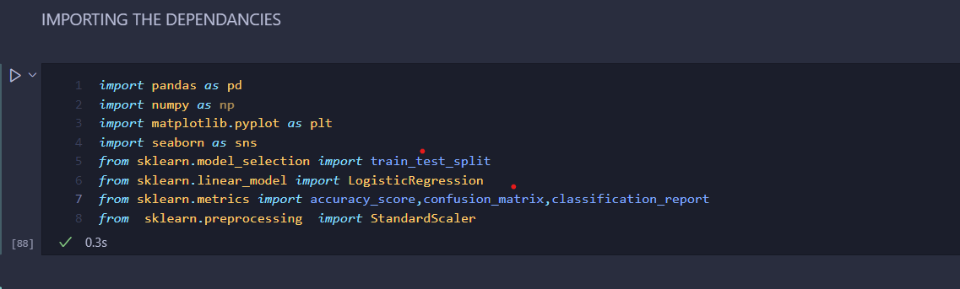
Import some libraries that are pandas (used for data manipulation and analysis and it comes from panel data), numpy (Known as ‘Numeric Python’ is a python library used to work with array), matplotlib(is a plotting library for python programming language) and seaborn (it is visualization library based on matplotlib)
UPLOAD THE DATASET
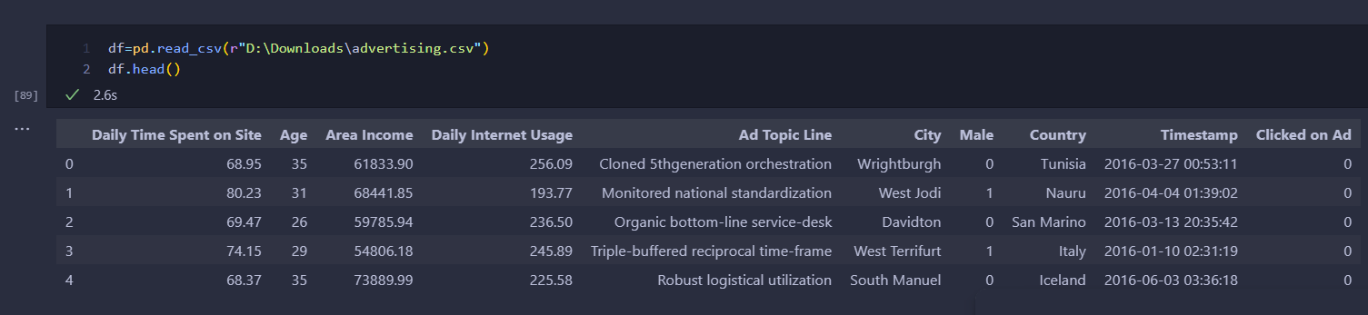
Upload the dataset taken from Kaggle. pd.read_csv() function reads data from a CSV file. Head() functions shows the first five rows of the dataset.

SPLITTING THE DATASET AND SELECTING THE MODEL
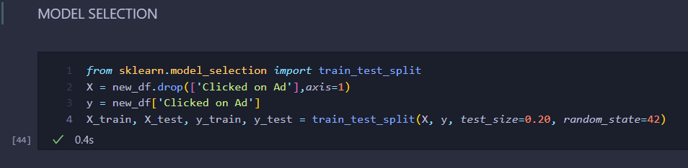
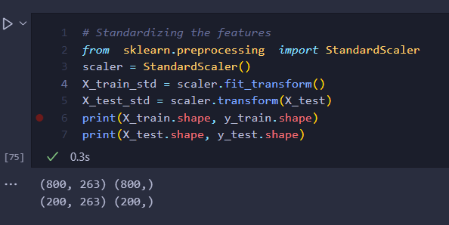
Scikit-learrn is a free software machine learning library for Python programming language. The train_test_split is imported from sklearn.model_selection which is used to split data into train (used in model building or to fit the model) and test (used to evaluate the performance or accuracy of the model) sets.
StandardScaler() is used when the datasets values lie in different ranges and do not have an equal contribution to the model fit parameters and training function and may lead to bias in the predictions made by the model. fit_transform() function is used to fit parameters of the data and transform it.
FEATURE ENGINEERING
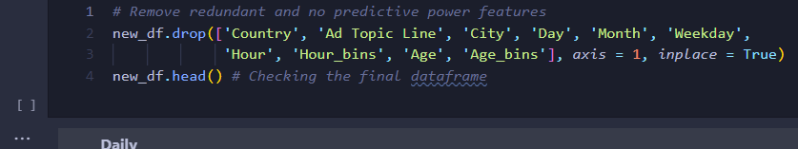
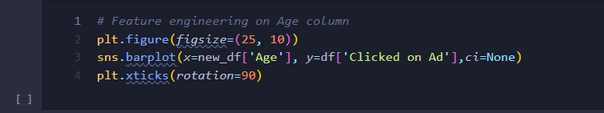
Feature engineering is the process of selecting, modifying, or creating new features (predictor variables) from raw data to improve the performance of machine learning models. It involves transforming data into a format that better represents the underlying problem to the predictive models, thus enhancing the model's ability to learn from the data.
TRAINING MODEL
In training the data, fit 80% of the trained data into the model. By using this, build the given model. This process involves learning the parameters (coefficients) that best map the input features to the target variable.
In logistic regression,
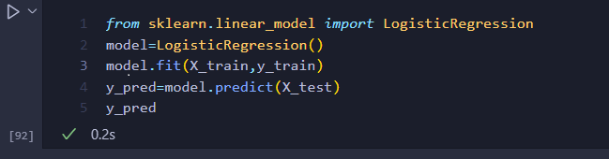
Import LogisticRegression algorithm from sklearn.linear_model and initialize the model and then feed the training dataset into algorithms using model.fit. y_pred is used to check the model prediction. Model prediction refers to the process of using a trained machine learning model to make predictions on new, unseen data. In the context of logistic regression, this typically involves predicting the probability that a given input belongs to a particular class and then assigning the class label based on that probability.

In Decision Tree,
It involves creating a tree-like structure where each internal node represents a decision based on a feature, each branch represents an outcome of that decision, and each leaf node represents a final prediction (a class label in classification tasks, or a value in regression tasks).
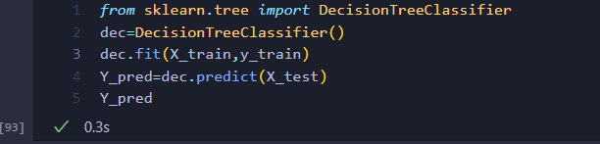
Import DecisionTreeClassifier from sklearn.tree and initialize it and then feed the training dataset into the algorithms using dec.fit. y_pred is used to check the model prediction.

EVALUATING THE MODEL
Several metrics are used to evaluate the performance of a logistic regression model, particularly in binary classification tasks: ACCURACY: Accuracy measures the proportion of correctly predicted instances out of the total instances. It is suitable when the classes are balanced.
Accuracy=Number of Correct Predictions​/Total number of Predictions ​
Import accuracy_score from sklearn.metrics and initialize acc_score to test and prediction and then print the accuracy score
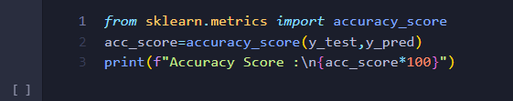
Accuracy Score: 94.5
CONFUSION MATRIX: The confusion matrix provides a summary of prediction results on a classification problem. It shows the number of true positive (TP), true negative (TN), false positive (FP), and false negative (FN) predictions.
 | Predicted Positive | Predicted Negative
Actual Negative | FP | TN
Actual Positive | TP | FN
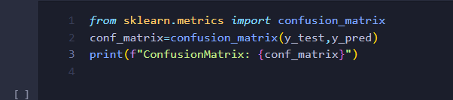

ConfusionMatrix: [[ 87 2]
[ 9 102]]
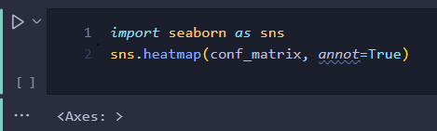
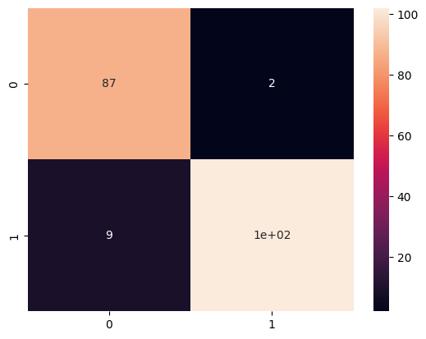
CLASSIFICATION REPORT
A classification report is a performance evaluation metric in machine learning that provides a detailed breakdown of a classifier’s performance across multiple classes. It is particularly useful for binary and multiclass classification problems. The classification report includes several key metrics for each class, such as precision, recall, F1-score, and support.
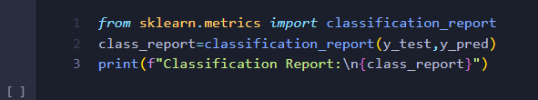
Classification Report:
precision recall f1-score support

0 0.91 0.98 0.94 89
1 0.98 0.92 0.95 111

accuracy 0.94 200
macro avg 0.94 0.95 0.94 200
weighted avg 0.95 0.94 0.95 200

Precision: also known as the positive predictive value, measures the accuracy of the positive predictions made by the model. It is the ratio of correctly predicted positive observations to the total predicted positives. Precision= True Positives (TP)/ True Positives (TP) + False Positives (FP) Precision answers the question: "Of all the instances that were predicted as positive, how many were actually positive?"
Recall: also known as sensitivity or true positive rate, measures the ability of the model to correctly identify all the positive instances. It is the ratio of correctly predicted positive observations to all the actual positives. Recall= True Positives (TP)/ True Positives (TP) + False Negatives (FN). Recall answers the question: "Of all the instances that were actually positive, how many did the model correctly identify as positive?"
F1-Score: is the harmonic mean of precision and recall. It provides a single metric that balances both precision and recall, especially useful when you need a balance between the two or when you have imbalanced class distributions. F1-Score=2(Precision*Recall​/ Precision+Recall). The F1-score is useful when both precision and recall are equally important, and you want a single metric to represent the performance.
Support: is the number of actual occurrences of each class in the specified dataset. It indicates how many instances there are for each class in the test data. Support = Number of actual instances for each class. Support helps to understand the distribution of classes in the dataset and to verify if the model performs well across all classes or if there is a performance disparity.

7) RESULT AND DISCUSSION
The accuracy score, confusion matrix and classification report shows the performance of a model trained on a click ad prediction dataset, evaluating its ability to predict whether a user will click on an ad. The classification report shows that the model has good performance with an accuracy of 94.5%, which is a good result for a click ad prediction dataset.
Analysis:
- High Accuracy (0.94) which indicates the model is generally accurate in predicting click behaviour.
- Good F1-Score (0.94) suggests a good balance between precision and recall, indicating the model is effective in both avoiding false positives and capturing true positives.
- Slightly Higher Recall for Class 1 (Clicks): The higher recall for class 1 (0.92) suggests the model is better at identifying true clicks, which is essential for optimizing ad campaigns.
- Slight Difference in Precision for Class 0 (No Clicks): While the precision for class 0 is slightly lower (0.91), it still performs well, indicating the model effectively filters out non-clicks.
The ad click prediction dataset works with the help of machine learning algorithms in this experiment to identify which algorithm works better with the ad click prediction. The best score of the performance of an algorithm lies between -1 and 1. To improve the algorithms by combining them with other algorithms and combining them with new technologies to produce more accurate results with the model
This model seems to be quite effective in predicting click behaviour. It can accurately identify both positive (clicks) and negative (non-clicks) cases with a good balance between precision and recall. Potential Improvements such as exploring hyper parameter tuning techniques to potentially improve model performance also by adding additional features like user demographics, ad content, and website context could further improve prediction accuracy. Evaluating more sophisticated models like deep learning algorithms for potential further improvement.
Overall, the model demonstrates strong performance, indicating its potential usefulness in various applications related to click ad prediction.

8) CONCLUSION
Finally, we have trained a logistic regression model and calculated the probabilities for ads that are predicted to be clicked. In reality, we will compare the models with log loss as we need actual probabilities in this case. Once we have got the probabilities, we will multiple those with the bid amount given by each ad representative. The resulted product will then be sorted out in descending order and the top 3 would be chosen to be displayed as ads by the search engine. This is the concept of ad click prediction and how the companies maximize their revenue and at the same time offering adequate results.
After developing and evaluating the ad clicking prediction model, several conclusions can typically be drawn as the model’s ability to predict ad clicks can be evaluated using metrics such as accuracy, precision, recall, F1-score, and AUC-ROC. A well-performing model would show high values in these metrics, indicating reliable predictions. The results can guide advertisers on how to segment their audience for targeted ad campaigns. For instance, ads for certain products might perform better with a specific demographic, allowing for more effective segmentation. Ultimately, the effectiveness of the prediction model should translate into tangible business outcomes, such as increased click-through rates (CTR), higher conversion rates, and better ad revenue. The ad clicking prediction dataset aims to empower advertisers with predictive insights that drive more effective and efficient ad campaigns. By accurately predicting ad clicks, businesses can enhance user engagement, optimize ad spend, and ultimately achieve better marketing outcomes. The conclusion of such a dataset analysis will often reflect the model's predictive accuracy, the understanding of key influencing factors, and recommendations for strategic improvements in advertising efforts.


9) SCOPE FOR FUTURE ENHANCEMENT
Enhancing the dataset and model in these areas will likely improve the overall performance, accuracy, and reliability of ad click prediction systems. These enhancements such as feature engineering, advanced modelling techniques, pre-processing, bias detection etc. will help you create a more accurate, personalized, and ethical ad click prediction model.
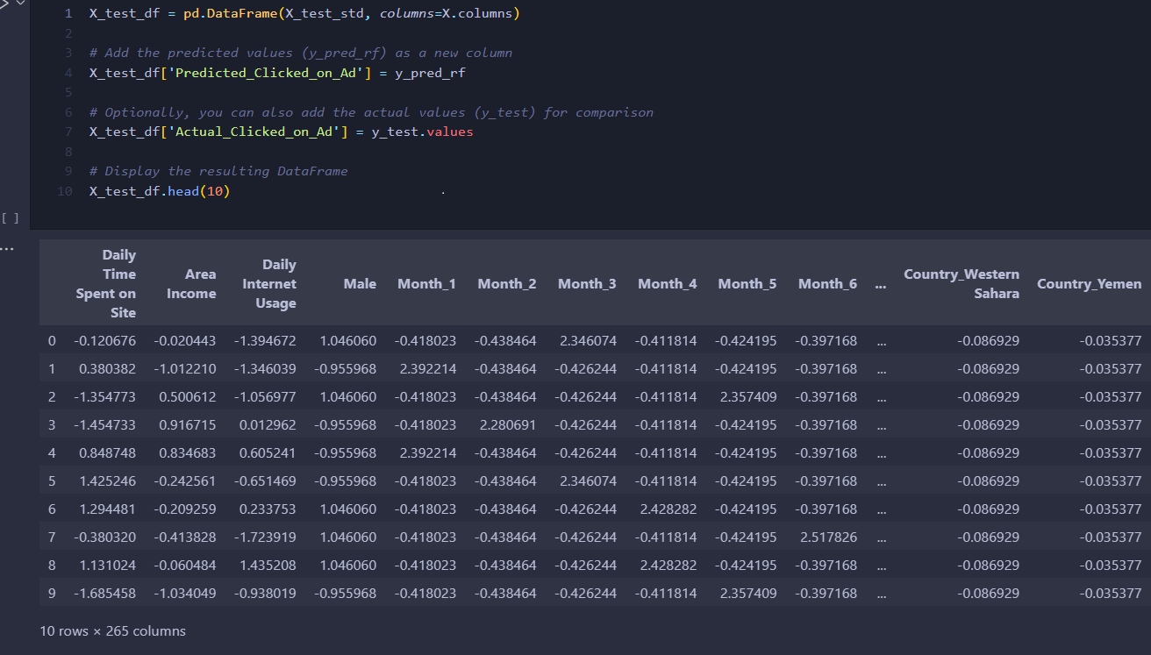

10) APPENDIX
Source code:
import pandas as pd
import numpy as np
import matplotlib.pyplot as plt
df=pd.read_csv(r"D:\Downloads\advertising.csv")
df
df.shape
df.isna().sum()
df.columns
numeric_cols = ['Daily Time Spent on Site', 'Age', 'Area Income', 'Daily Internet Usage' ]
numeric_cols
Categorical_cols = [ 'Ad Topic Line', 'City', 'Male', 'Country', 'Clicked on Ad' ]
Categorical_cols
df[Categorical_cols].describe(include = ['O'])
new_df = df.copy()
new_df = pd.concat([new_df, pd.get_dummies(new_df['Weekday'], prefix='Weekday')], axis=1)
plt.figure(figsize=(25, 10))
sns.barplot(x=new_df['Age'], y=df['Clicked on Ad'],ci=None)
plt.xticks(rotation=90)
from sklearn.model_selection import train_test_split
X = new_df.drop(['Clicked on Ad'],axis=1)
y = new_df['Clicked on Ad']
X_train, X_test, y_train, y_test = train_test_split(X, y, test_size=0.20, random_state=42)
from sklearn.preprocessing import StandardScaler
scaler = StandardScaler()
X_train_std = scaler.fit_transform(X)
X_test_std = scaler.transform(X_test)
print(X_train.shape, y_train.shape)
print(X_test.shape, y_test.shape)
from sklearn.linear_model import LogisticRegression
model=LogisticRegression()
model.fit(X_train,y_train)
y_pred=model.predict(X_test)
y_pred
from sklearn.tree import DecisionTreeClassifier
dec=DecisionTreeClassifier()
dec.fit(X_train,y_train)
Y_pred=dec.predict(X_test)
Y_pred
y_pred=model.predict(X_test)
print(y_pred, y_test)
from sklearn.metrics import accuracy_score
accuracy = accuracy_score(y_test, y_pred)
print(f"Accuracy: {accuracy:.2f}")
from sklearn.metrics import confusion_matrix
conf_matrix=confusion_matrix(y_test,y_pred)
print(f"ConfusionMatrix :\n{conf_matrix}")
from sklearn.metrics import classification_report
class_report=classification_report(y_test,y_pred)
print(f"Classification Report:\n{class_report}")
import seaborn as sns
sns.heatmap(conf_matrix, annot=True)
X_test_df = pd.DataFrame(X_test_std, columns=X.columns)
X_test_df['Predicted_Clicked_on_Ad'] = y_pred_rf
X_test_df['Actual_Clicked_on_Ad'] = y_test.values
X_test_df.head(10)
12) BIBLIOGRAPHY

Websites Referred:
https://www.kaggle.com/code/mafrojaakter/customer-ad-click-prediction
https://medium.com/geekculture/ad-click-prediction-what-why-and-how-bee259ddb05c
https://dl.acm.org/doi/abs/10.1145/2487575.2488200
https://towardsdatascience.com/online-ad-click-prediction-with-machine-learning-b68c1467d960
https://www.geeksforgeeks.org/click-through-rate-prediction/

